6th Grade Course Description
At the end of sixth grade, students should be able to:
- Understand what ratios are and be able to use ration reasoning to solve problems.
- Apply knowledge of multiplication and division to divide fractions by fractions.
- Multiply and divide multi-digit numbers to find common factors and multiples.
- Apply numbers in the system of rational numbers.
- Apply arithmetic to algebraic expressions.
- Reason and solve one-variable equations and inequalities.
- Represent and analyze quantitative relationships between dependent and independent variables.
- Solve real world problems involving area, surface area, and volume.
- Develop an understanding of statistical variability.
Gifted/Advanced Math:
Sixth grade Gifted math will be organized around the following thematic units, in accordance to the Georgia Gifted Association’s recommendations for gifted students. This states that the curriculum is rigorous and relevant to accommodate the intellectual needs of gifted learners. The gifted curriculum will be enhanced using the strategies of higher level thinking, such as Bloom’s Taxonomy of Critical Thought and Williams’ Taxonomy of Creative Thought.

- Summarize and describe distributions.

Students will also develop the following Standards for Mathematical Practice while learning the above content:
- Make sense of problems and persevere in solving them.
- Reason abstractly and quantitatively.
- Construct viable arguments and critique the reasoning of others.
- Model with mathematics.
- Use appropriate tools strategically.
- Attend to precision.
- Look for and make use of structure.
- Look for and express regularity in repeated reasoning.

Materials
  - A 1 or 2 inch 3-ring binder (for math only)
  - One 3-prong folder (for creating OMG flipbook)
  - Loose-leaf notebook paper
  - Pencils—No pens please!
  - A hand-held pencil sharpener
  - Scissors, glue, markers or crayons

Organization
- Each student is responsible for keeping handouts, notes, and all completed work for each unit.
- Tests/Quizzes will be given throughout/or at the end of each unit.
- Each student is responsible for keeping graded papers.
- Students are also responsible for copying assignments in the agenda each day in class and showing it to parents.

Class Participation
Students’ ideas and thought processes are important to the success in math class this year. We will constantly reflect on previous lessons as well as current ones.As a student, you should:
- Try to be present everyday.
- Be an active participant in class discussions.
- Question whenever necessary.
- Do your best and keep organized.

Grading Policy
50% | Daily | In-class assignments, maintenance, etc.
25% | Tests | Major tasks, mid-chapter tests, unit tests
15% | Quizzes | Expect a quiz every 1-2 weeks
10% | Benchmark | Cumulative for the grading period
Homework Policy
Homework is designed to help a student learn! It is not always graded with respect to right or wrong answers, but instead by how much effort a student has given. Students should return to class the following day with questions about specific problems. Parents, please encourage this philosophy of math homework at your home!

A Math Maintenance page will be given every Monday and due on Friday.Additional homework assignments may also be given each week. All homework is due when the student enters the classroom. It should be neat and legible. All math work is to be completed in pencil.
Students not turning in assignments on time will receive a “Not Prepared” mark in their behavior log.

Time Outside of Class

You cannot expect to accomplish what you should from this course without spending time with math outside of class. As well as completing daily homework assignments, you need to stay organized, spend time reviewing notes and assignments, carefully reflect on problems previously missed, etc. It is my expectation that you spend approximately 15-20 minutes each evening (Mon-Thurs) with homework and use the weekend to study, work on projects, review, get caught up, etc. Please communicate with me as soon as possible if you are having trouble managing your time or if you find you are spending significantly more than 15-20 minutes an evening working on math. I truly want to help you get the most out of this course you can.

Tutorial
Tutorial assistance is offered on an as-needed basis; if you feel that you need extra help, arrangements can be made either before or after school. Tutorial is not a substitute for participation and hard work during class time; it is meant to be a supplement to the math class.

Website
Please refer to my website for classroom news/resources, sixth grade documents, and our picture gallery. I update my website once a week and will be a great tool for both parents and students to use on a regular basis. I post when upcoming test/quizzes, weekly homework, and online video tutorials over topics we are learning in class. www.westmorelandmath.weebly.com

Parents and students: Please sign below to indicate that you have read through the expectations for 6th grade math class. Signing and returning the syllabus by Tuesday, August 9th is your first assignment!

Student Signature: __________________ Parent/Guardian Signature:____________________
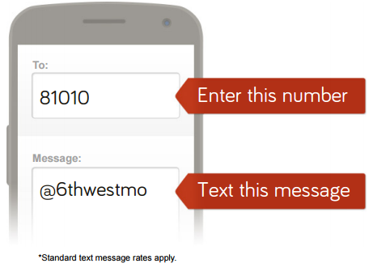
To Stay Informed...
To receive important text reminders without exchanging personal information, please send the following text message to the number shown. You will receive texts but will not be able to reply. To contact Ms. Salter, send an email or call the school 706-625-9545.

For more info, visit remind101.com

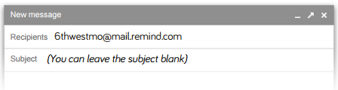
Or to receive messages via email, send an email to 6thwestmo@mail.remind.com. To unsubscribe, reply with ‘unsubscribe’ in the subject line.
Or to receive messages via email, send an email to west6th@mail.remind.com. To unsubscribe, reply with ‘unsubscribe’ in the subject line
Or to receive messages via email, send an email to west6th@mail.remind.com. To unsubscribe, reply with ‘unsubscribe’ in the subject line
Or to receive messages via email, send an email to west6th@mail.remind.com. To unsubscribe, reply with ‘unsubscribe’ in the subject line

